**Appendix 1**

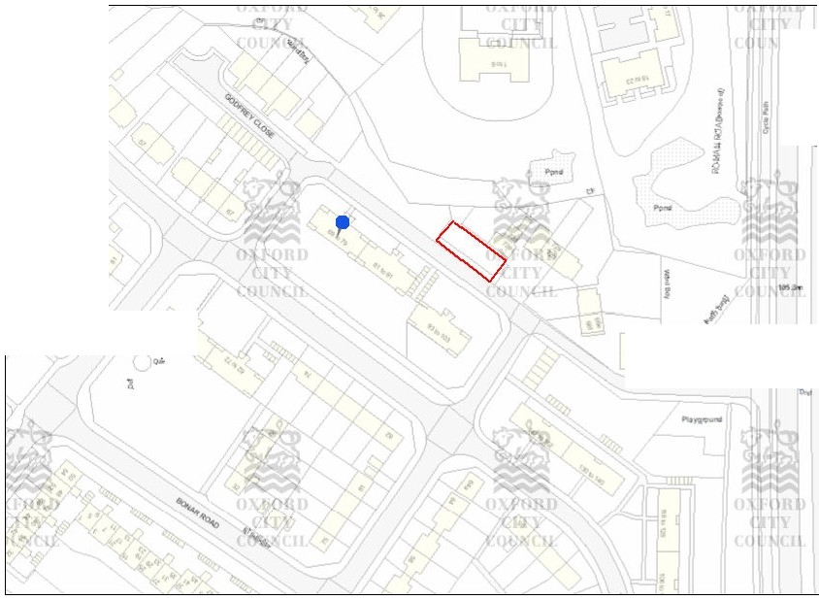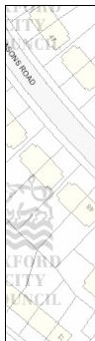

r-

**r**

**.o..** N

*A*

*I*

Q

•

X

:

f

>-

d

7

3

...

l



'

•

14!00052/CT3

Scale (printed toM): 1:1,250

0 10 20 30 40

-=--c:==--Metres

(c) Crown Copyright and database right 2014. Ordnance Survey 100019348.



Date: 24!02.2014